Assignment 2: Version Control with Git
- Aim:
To initialize a Git repository, create and modify files, perform commits, create branches, and merge branches by resolving conflicts.
2. Objective
- Understand Git workflow
- Learn branching and merging
- Handle merge conflicts
4. Procedure
Step 1: Create Project Directory
Step 2: Initialize Git Repository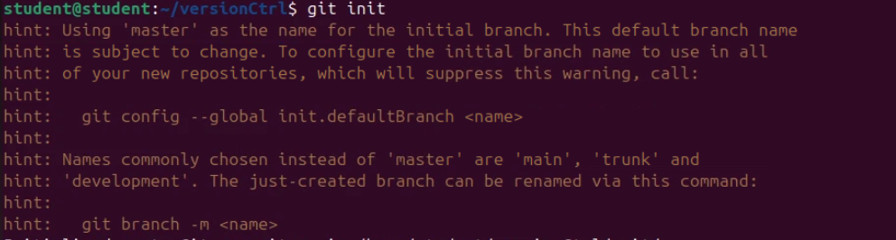
Step 3: Create Source Folder
Step 4: Create Files
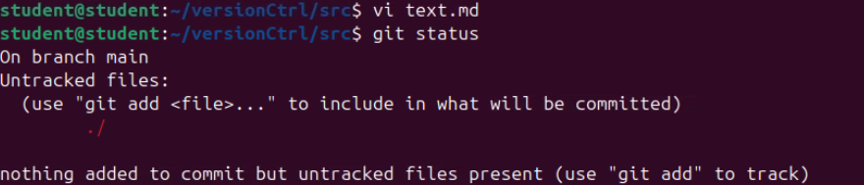

Step 5: Add and Commit Files
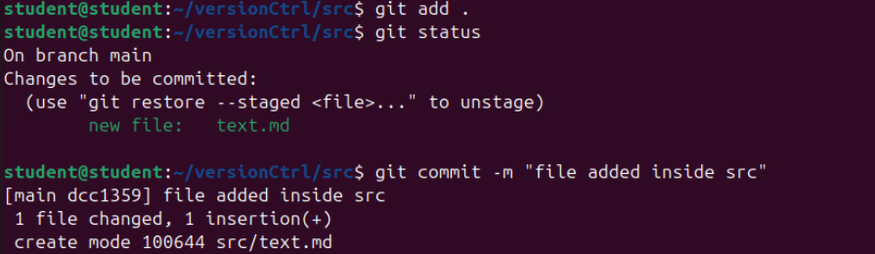
Step 6: Create a New Branch
Step 7: Modify Files in Feature Branch

Step 8: Switch to Main Branch
Step 9: Modify File in Main Branch

Step 10: Merge Branches
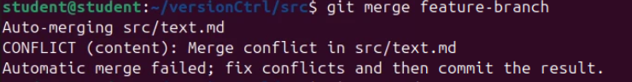
Step 11: Resolve Merge Conflict

Step 12: Final Commit
Step 13: View Commit History
